**

**Gelmaat Model Priviledge Grants**

**Semarchy xDM**

www.amplifiuk.com

+44 (0) 1926 911820

Third Floor, Marlborough House

48 Holly Walk, Leamington Spa

CV32 4XP, United Kingdom

Contents

1 Introduction 3

2 Platform 3

2.1 Change and Release Management 3

2.2 Investigating Data Load Issues 4

2.3 Debugging and Logs 5

2.4 Data Certification Process 5

2.5 User Access Management 5

2.6 Performance 5

2.7 SemQL 6

3 Application 6

3.1 ‘Safe’ Changes 6

3.2 ‘Breaking’ Changes 6

3.3 Managing Integration Impacts 7

# Geldmaat Change Desk User

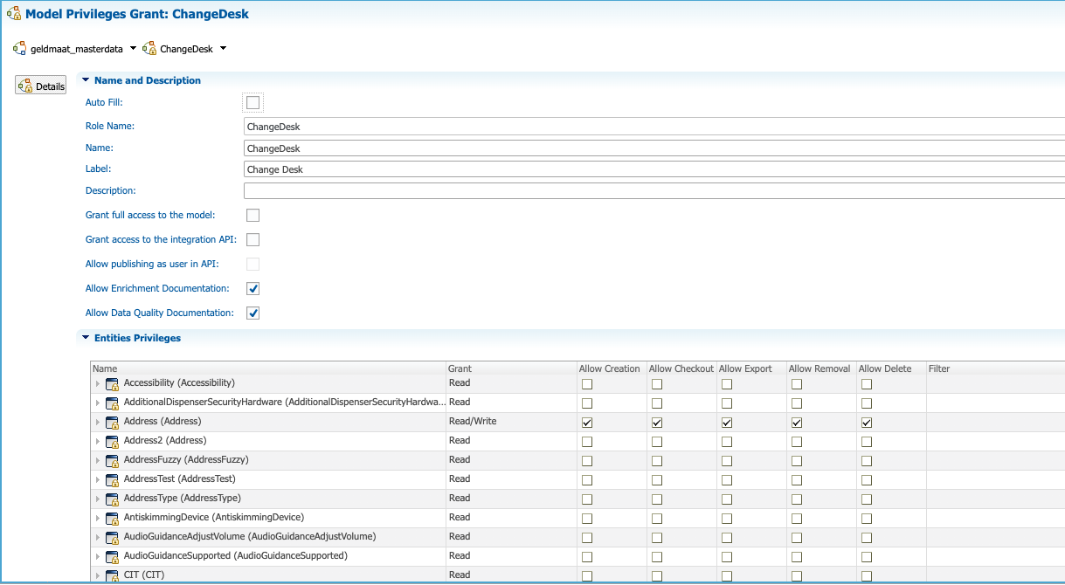

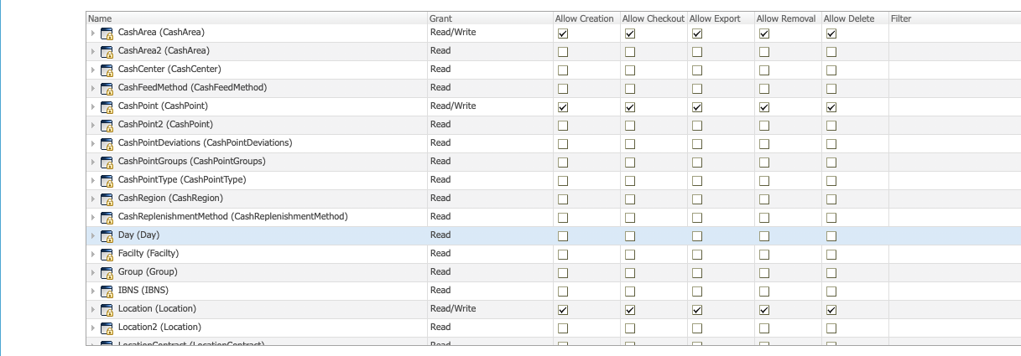

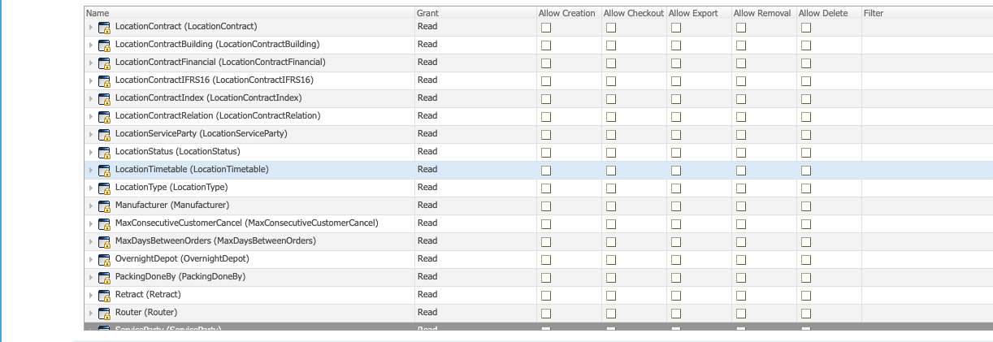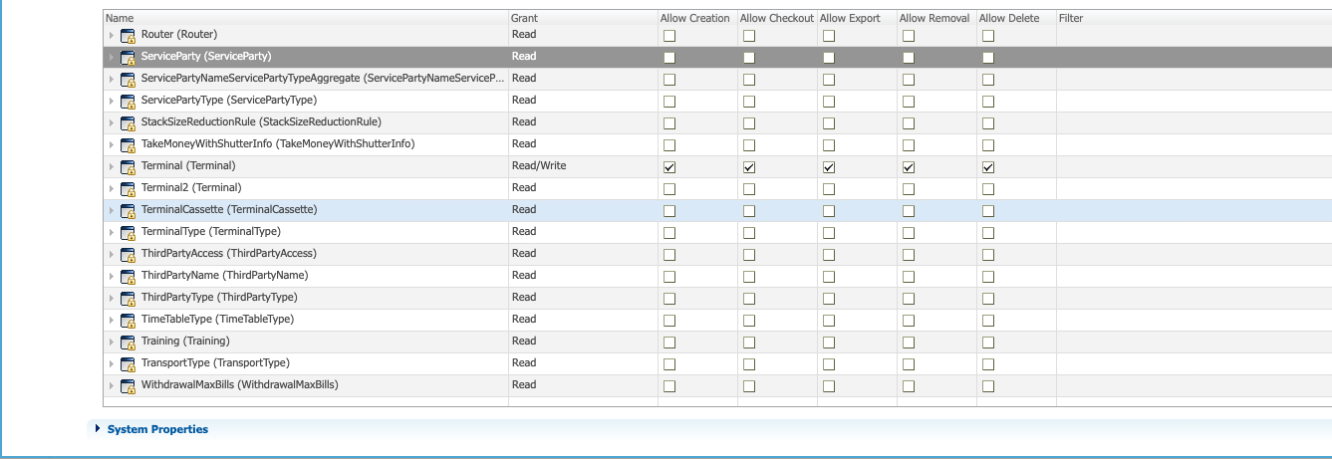

# Geldmaat Change Desk Manager

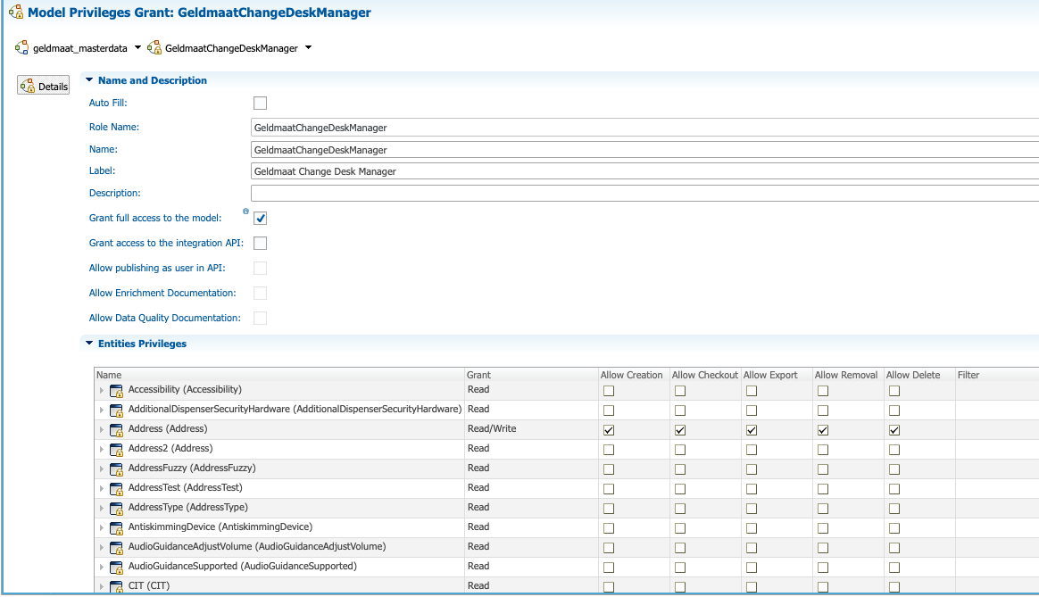







## Geldmaat Data Steward

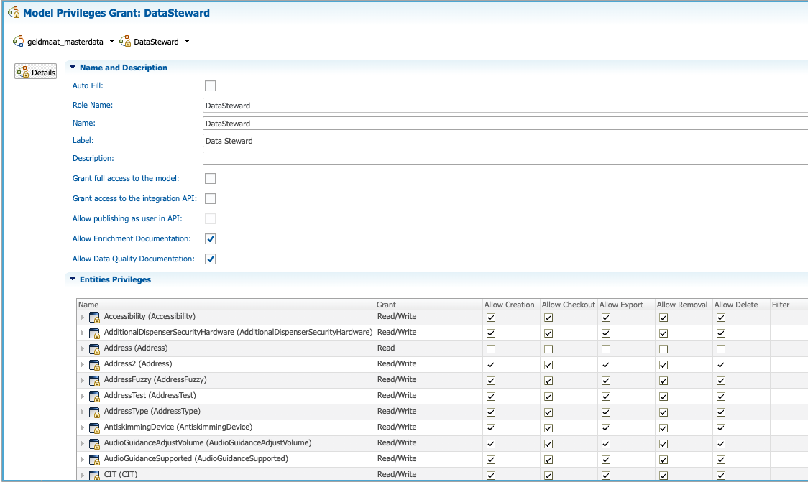

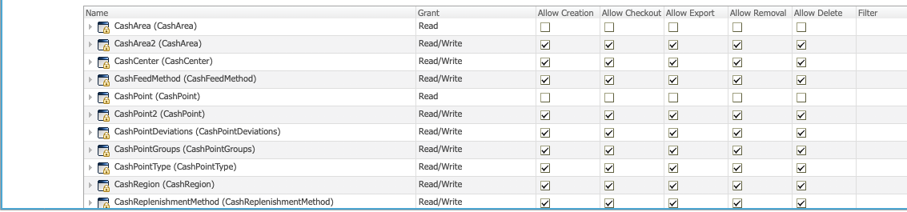

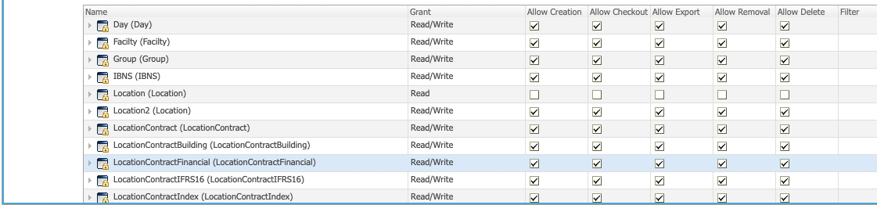

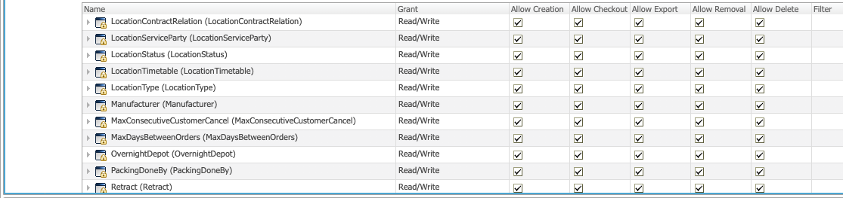

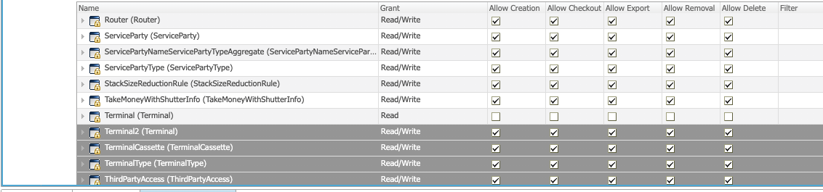

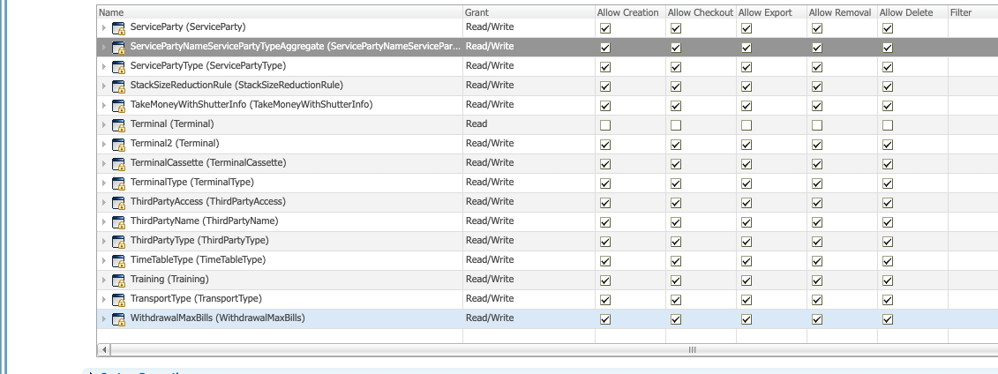

## Geldmaat DMO

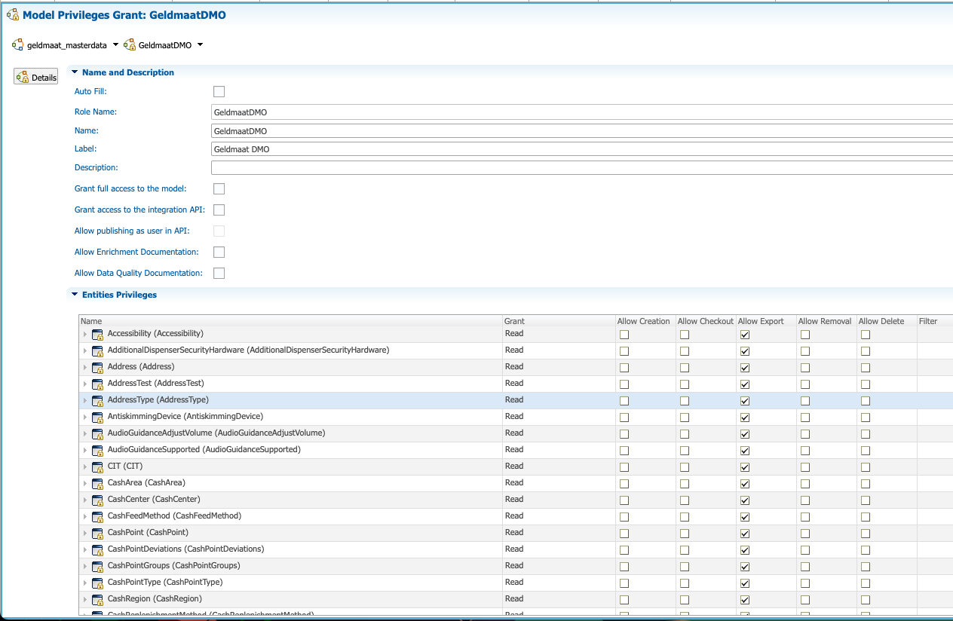

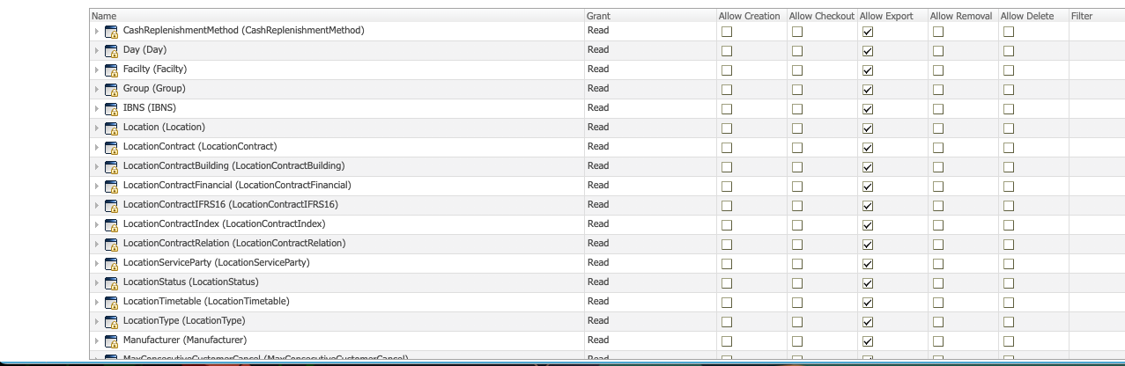

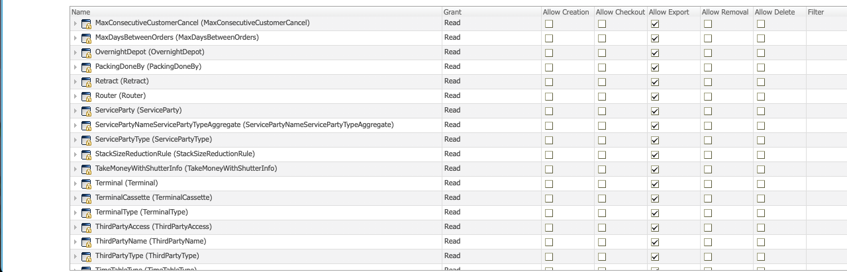

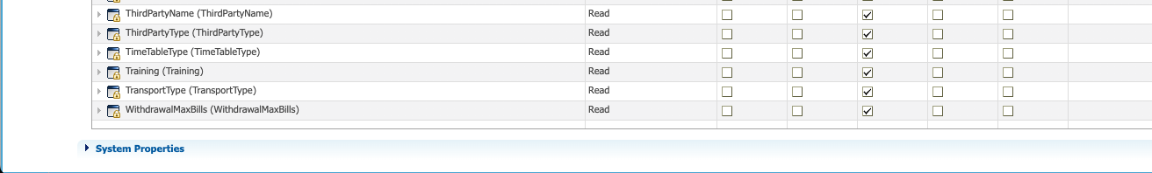

# Geldmaat Semarchy Admin

